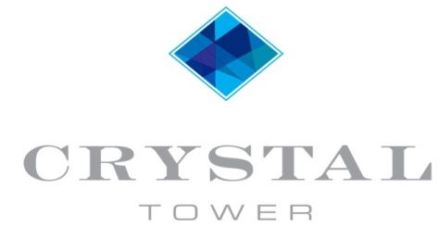

ELEVATOR UPDATE

The renovations to elevator 3 are complete and the elevator has been turned over for operation. With a few adjustments it has been running well since.

The renovations took 7 weeks to complete the first elevator and now that the technicians are familiar with the process we are hopeful that the remaining elevators won’t take as long to complete. We anticipate that the project will be completed on the date provided by our elevator company, June 26, 2017.

Here are some pictures of the process to give you an idea of what has been replaced.
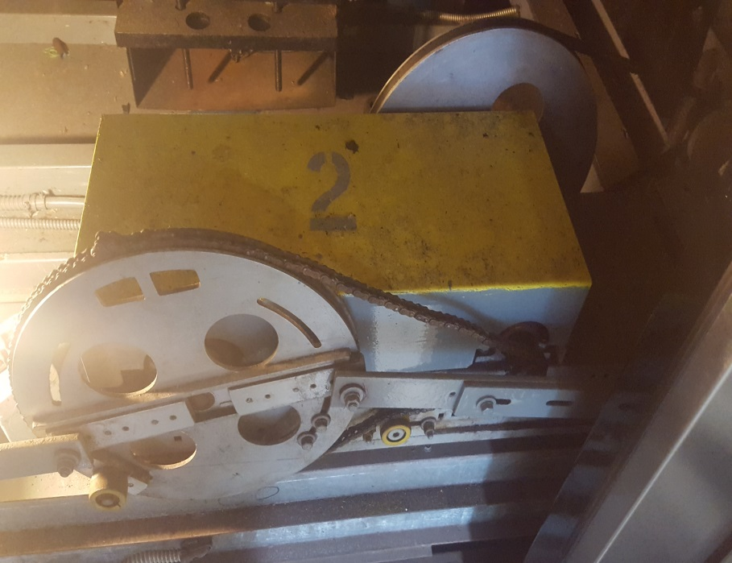
The old operating system was chain driven.
The chain had rusted over the years causing a poor opening and closing operation and slow doors.

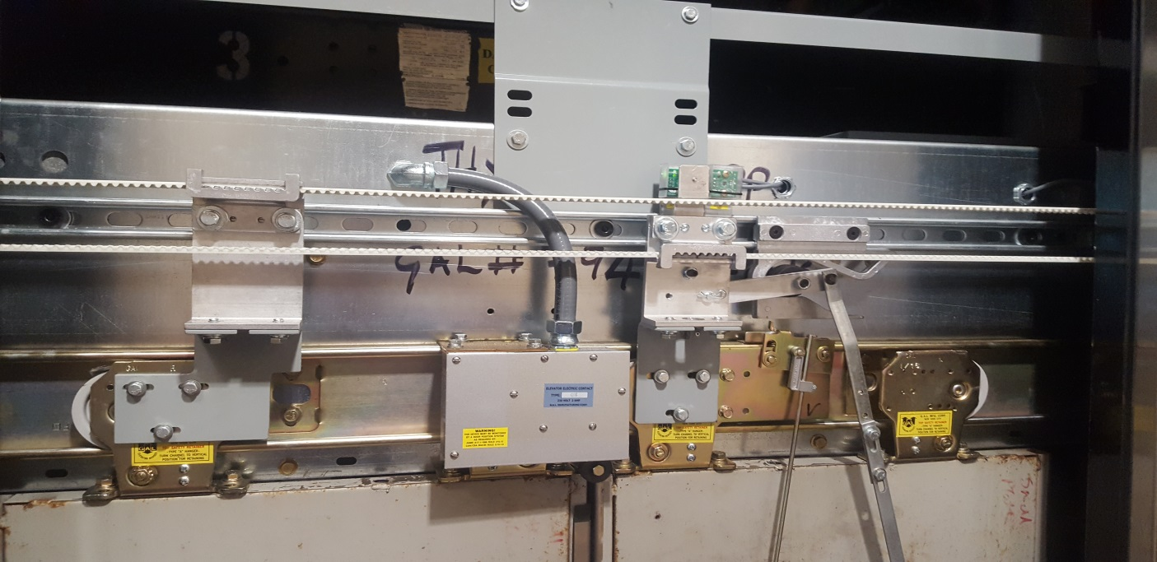
The new belt driven linear operator spans the entire length of the door and is fastened with zinc plated hardware. The operator itself is also comprised of stainless steel and zinc plated materials. It will provide smooth and reliable opening and closing operation and will last much longer than the old operator.

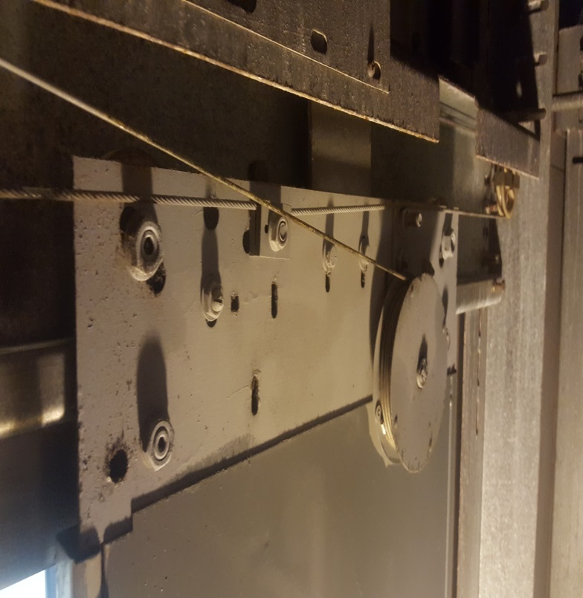

The old rollers, tracks and corresponding cables can be seen on the left. These tracks need to be clean and clear of debris for proper operation. Even the slightest bump in the tracks can cause problems. Corrosion and rust on the old tracks contributed to many of the problems we experienced with shutdowns.
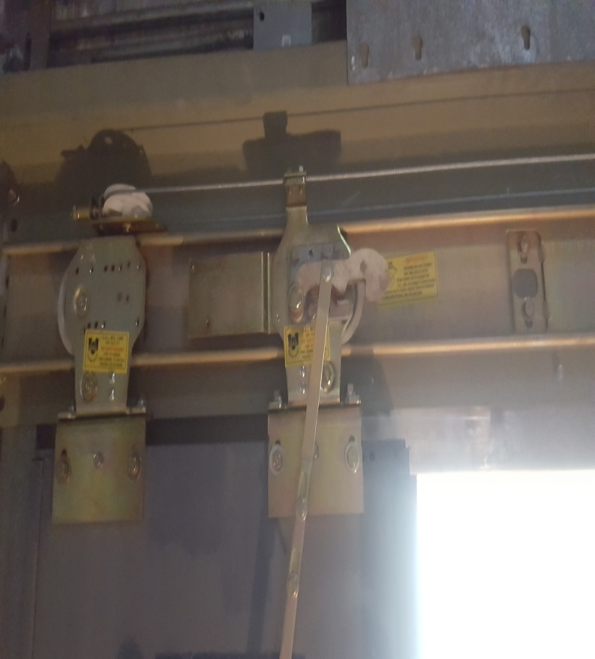
The new tracks and rollers are zinc plated and much sturdier than the old equipment and fastened with either stainless or zinc plated hardware. This aids in a much smoother operation. This was a long and loud process to replace the rollers at each opening for all twenty stories. Not only are the rollers new, the headers they are mounted to have also been replaced to help inhibit any new rust from growing or spreading.

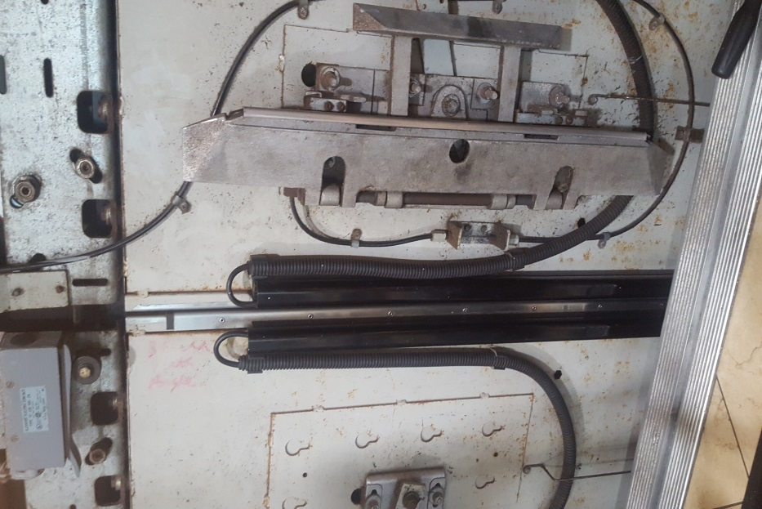
Pictured to the left are the old door edges and clutch. The clutch must be precisely adjusted on each floor for the interlocks to work properly. The old edges are the eyes of the door. They prevent the door from opening and closing if there is an obstruction in the way. We have experienced many issues with the door locks “clipping” which happens when the clutch is not adjusted properly or when parts of it starts going bad. Adjusting the old clutch had always been a temporary repair; the problem would always seem to reappear.
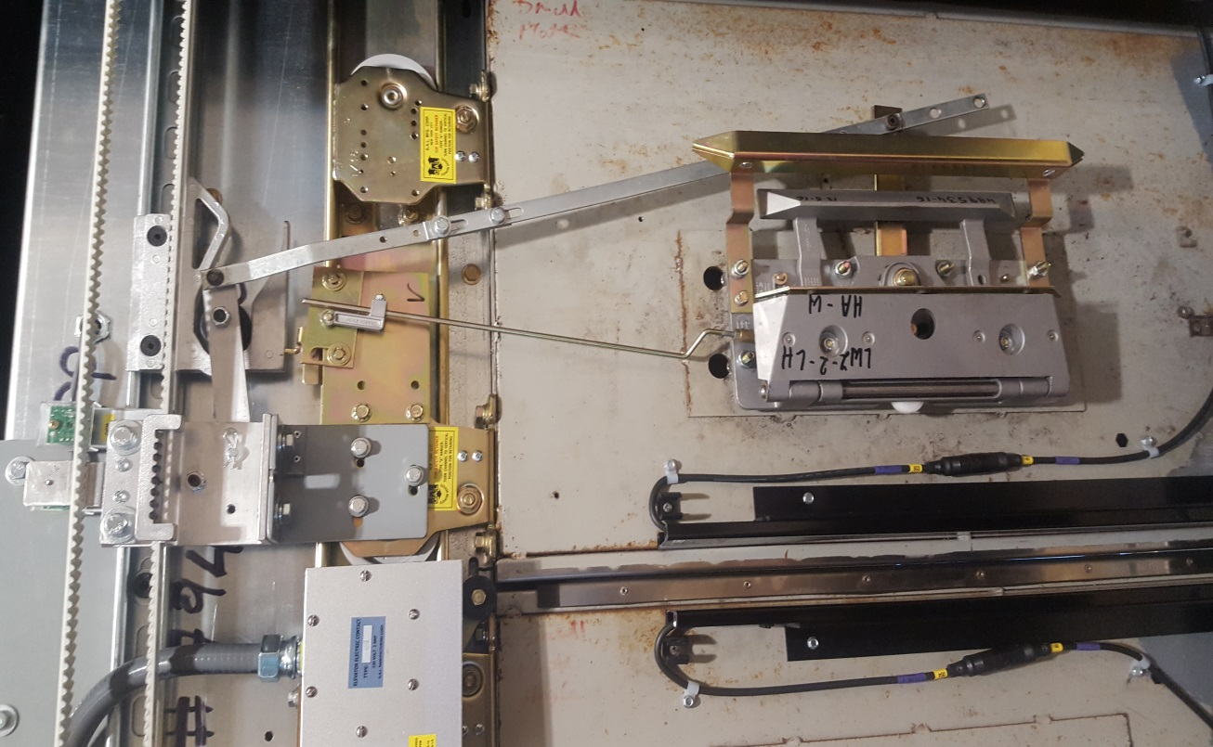
The new clutch and edges are now fastened to the doors with new hardware. The edges will also provide better limits to the door when opening and closing. You will be able to see the green lights on the edges when they are opening and red when they close.

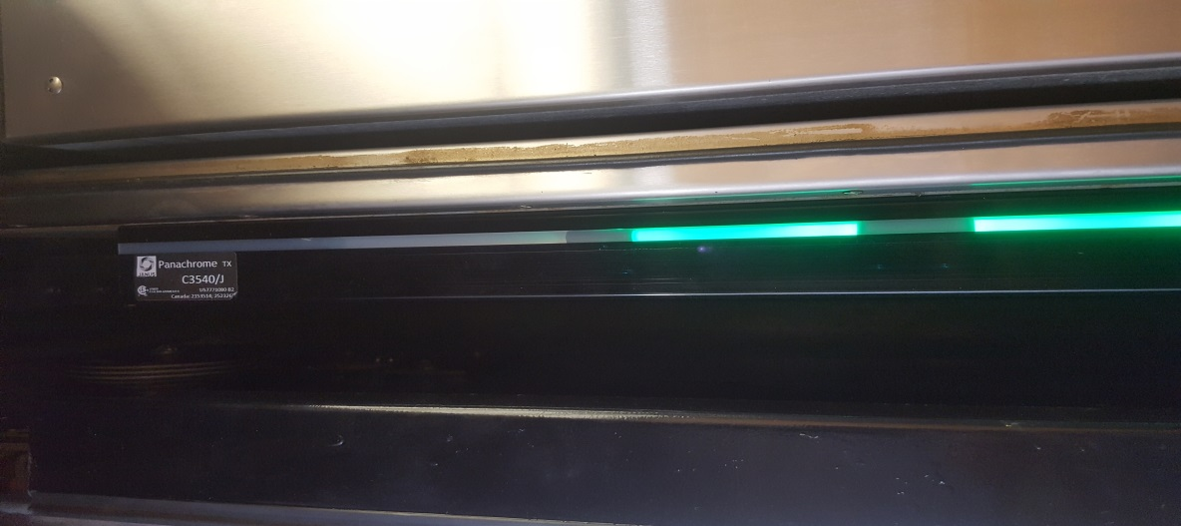
Color coded edges are a nice feature which will help prevent the door from timing out, this happens when the doors are held open too long and sometimes causes the elevator to shut down.

