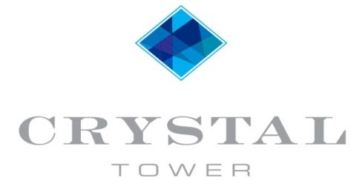
1010 WEST BEACH BOULEVARD
GULF SHORES, ALABAMA 36542

February 2017 Update

ELEVATOR UPDATE
The elevator project is underway and good progress is being made. It has taken longer than expected to get started, but now that the correct parts have arrived the technicians have been on site working full time.

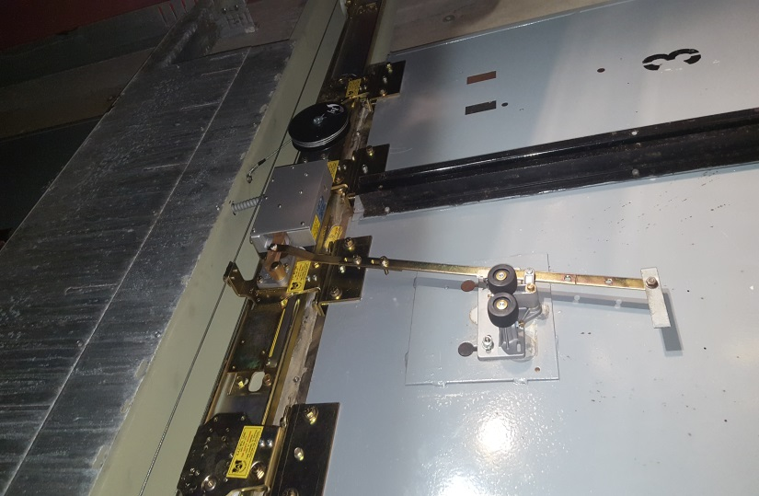
In the picture to the right you can see the newly installed door hardware. The headers, tracks, and roller guides have been removed and the newly coated ones installed. After every floor receives the new hardware the technicians will begin working on the door operating system.

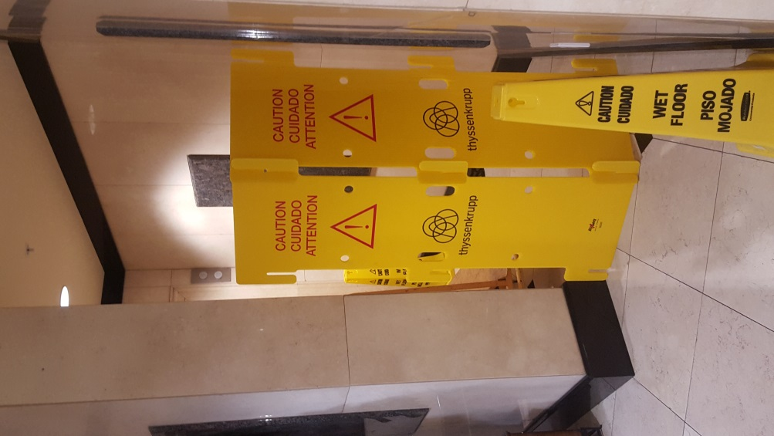
Only one elevator will be worked on at a time, leaving the other two elevators in operation. The project will continue until it is complete. The estimated completion date is June 26, 2017.

ANNUAL MEETING
Please set your calendars for this year’s Annual Meeting. The meeting will be held on the third Saturday of August – August 19, 2017 at 9 am. Several owners have expressed interest in holding the meeting earlier in the day, so the board decided to move it a week earlier in order to accommodate that. As we are nearing the date we will send notices just as we have in the past.

REMINDERS
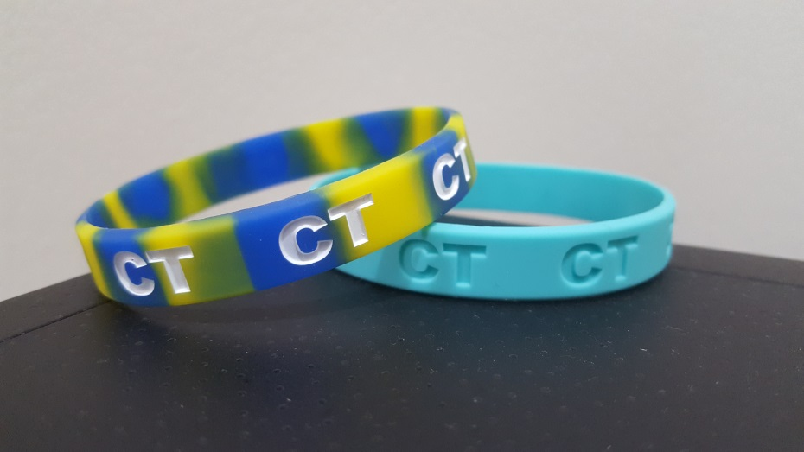
Please don’t forget we have switched to our new wristbands. Guest and owner wristbands are new colors – blue and yellow for guests and aqua for owners. Please make sure your guests have the proper color bands. You can purchase guest wristbands at the Young’s Suncoast office for $1 each (old unused wristbands still in the bags can be exchanged for new ones). There is no charge for owner wristbands and they can be picked up on site at Crystal Tower in the lobby.
We also have new colored parking permits. The new orange permits for rentals can be picked up at the Young’s Suncoast office for $20 each (you can exchange your old unused parking permit to receive a $10 credit towards new permits).
If you have family or friends using your condo and it is not a rental, you can pick up a free guest permit on site at Crystal Tower in the lobby.

BEACH SERVICE
Crystal Tower will have a new company providing beach service this upcoming year. The new contract has been awarded to Suncoast Beach Service and will begin in the spring. Owners will receive a 20% discount on regular fees and must pay with a credit card to receive the discount. Suncoast Beach Service can be reached at 251-968-2466.
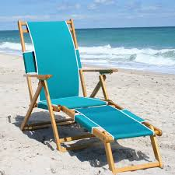
With the new “Leave No Footprints” ordinance, the city of Gulf Shores has been working with beach service companies to slowly phase out the use of lounges. Over the next 5 years, beach service companies will scale back the use of lounges by 20% each year until they are only using foldable chairs. This way chairs can be removed from the beach at night.
WATER SUPPLY LINES
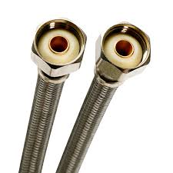
An email was sent to all owners at the beginning of the New Year instructing them that all water supply lines within units must be braided stainless steel or better. There are a number of units that still have rubber supply lines on their washing machines and plastic supply lines on their ice maker. Owners must ensure that these lines are upgraded to braided stainless steel or an improved supply line by April 1, or can face a $150 fine. If a leak occurs emanating from one of these sources, and the lines have not been upgraded, the owner will be responsible for payment of the repairs.
All water supply lines have a life expectancy. Toilet and sink supply lines also need to be changed out every 5 years. Some of these lines have caused leaks recently. The originally installed lines are braided stainless steel, but it is a good idea to replace those now also. Leaks emanating from these sources will also be the responsibility of the owner for the cost of repairs.
Please ensure your unit has the proper supply lines installed and notify the property manager, Joe Rynes (jrynes@youngssuncoast.com) by email once you have upgraded your lines.
DOOR LOCKS
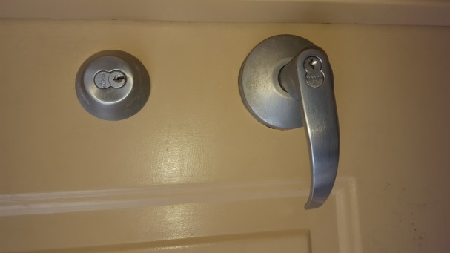
The Board of Directors have put in place a policy years ago that the only lock that can be installed on a unit’s front door, other than the original lock, is the Kaba 660K (which must specially ordered and IC prepped to receive a Crystal Tower core). It has been noted that several units have installed locks that are not in compliance with this policy – an email has been previously sent to owners who are not in compliance.
If you would like to install the Kaba 660K, please note that the lock MUST be IC prepped to receive a Crystal Tower core. The easiest way to ensure that you receive the correct lock would be to order it through Aaron’s Lock Service in Gulf Shores, 251-967-1919.
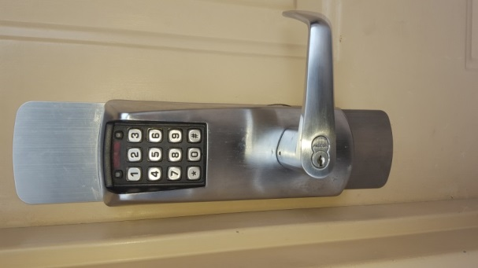
Owners who do not have the proper lock installed by March 15, 2017 could face a $150 fine.
If you have any questions regarding the lock please contact the property manager, Joe Rynes, by phone (251-968-5324) or email (jrynes@youngssuncoast.com).

