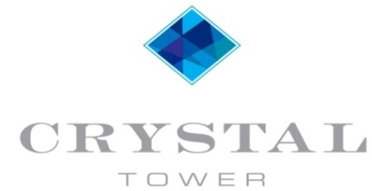
1010 WEST BEACH BOULEVARD
GULF SHORES, ALABAMA 36542

FRONT DOOR POLICY

Crystal Tower Owners

Re: Unit Front Door Locks

Dear Crystal Tower Owners,

The Board of Directors has implemented a policy limiting the type of door lock that can be installed to gain entrance to one’s unit. The only type of lock that has been approved for installation, other than the original falcon lock set, is the Kaba 660K. Furthermore, the Kaba 660K must be properly keyed so that it will accept the Crystal Tower IC core. Please contact the Association Property Manager at 251-968-5324 for further details.

The reasoning behind this is so access can be gained with only one master key in the event of an emergency, it also aides in keeping uniformity in the appearance of the property.

Thank you for your cooperation in this important matter.

Very Truly Yours,

The Crystal Tower Board of Directors

